Practical 2
Module name: requirement traceability matrix (rtm)
Test case id: mahipal70
Webpage url: https://opensource-demo.orangehrmlive.com

Scenario 01: Verify Requirement module opens successfully
Test case id :TC_01

Test steps:
Navigate to Recruitment > Requirement
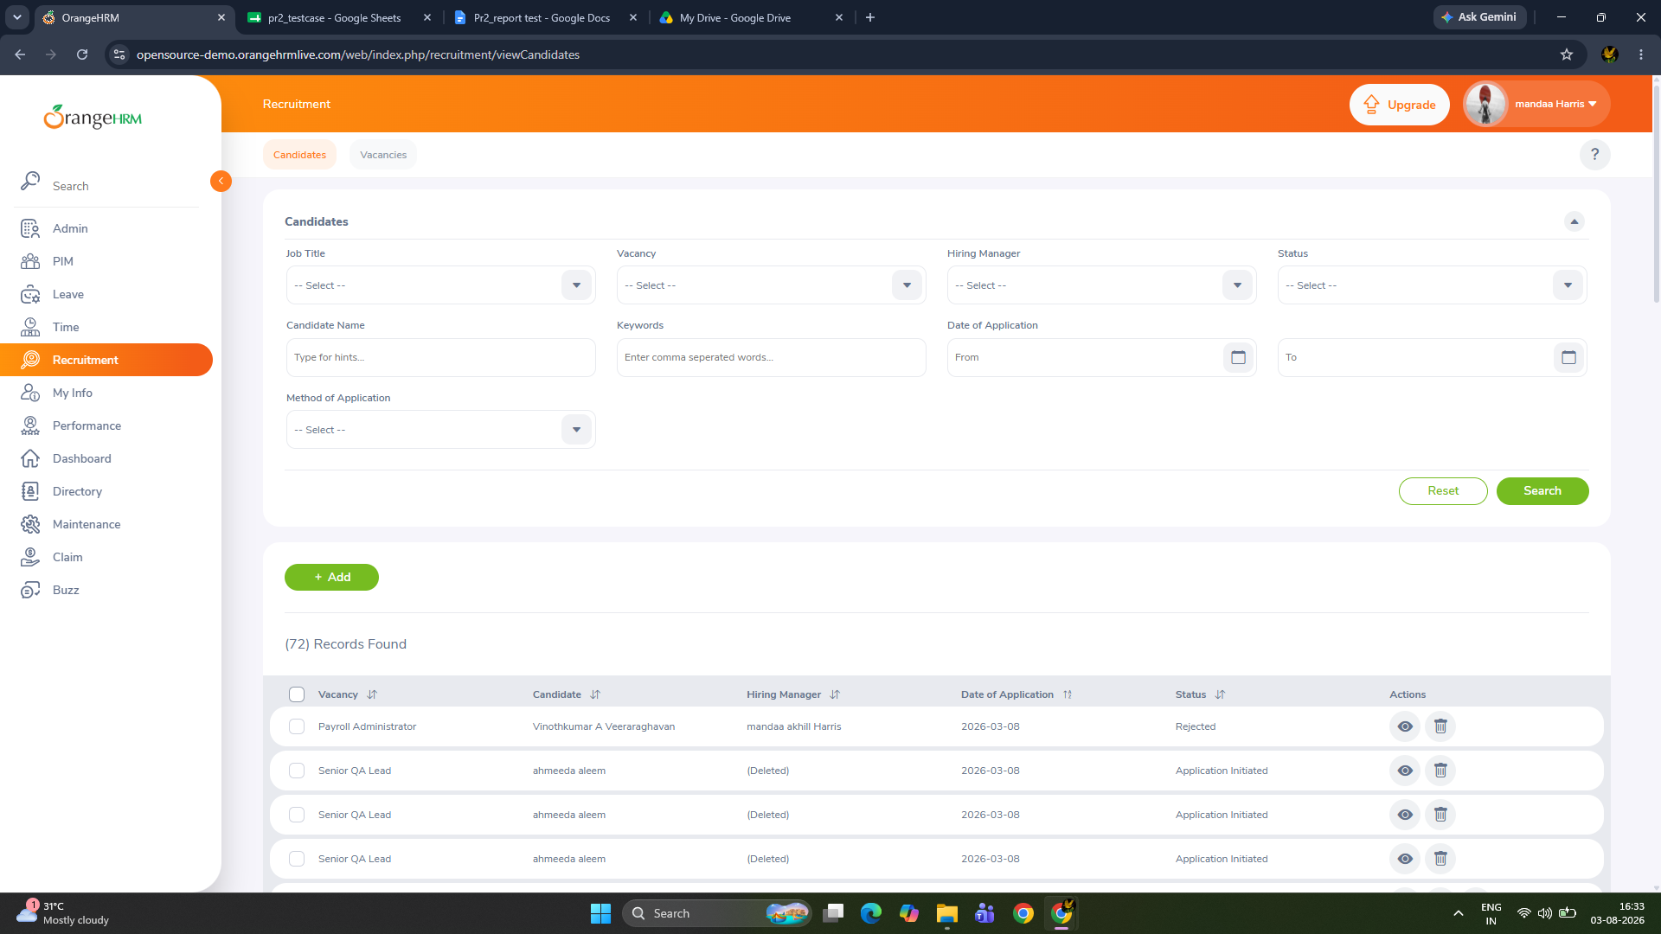
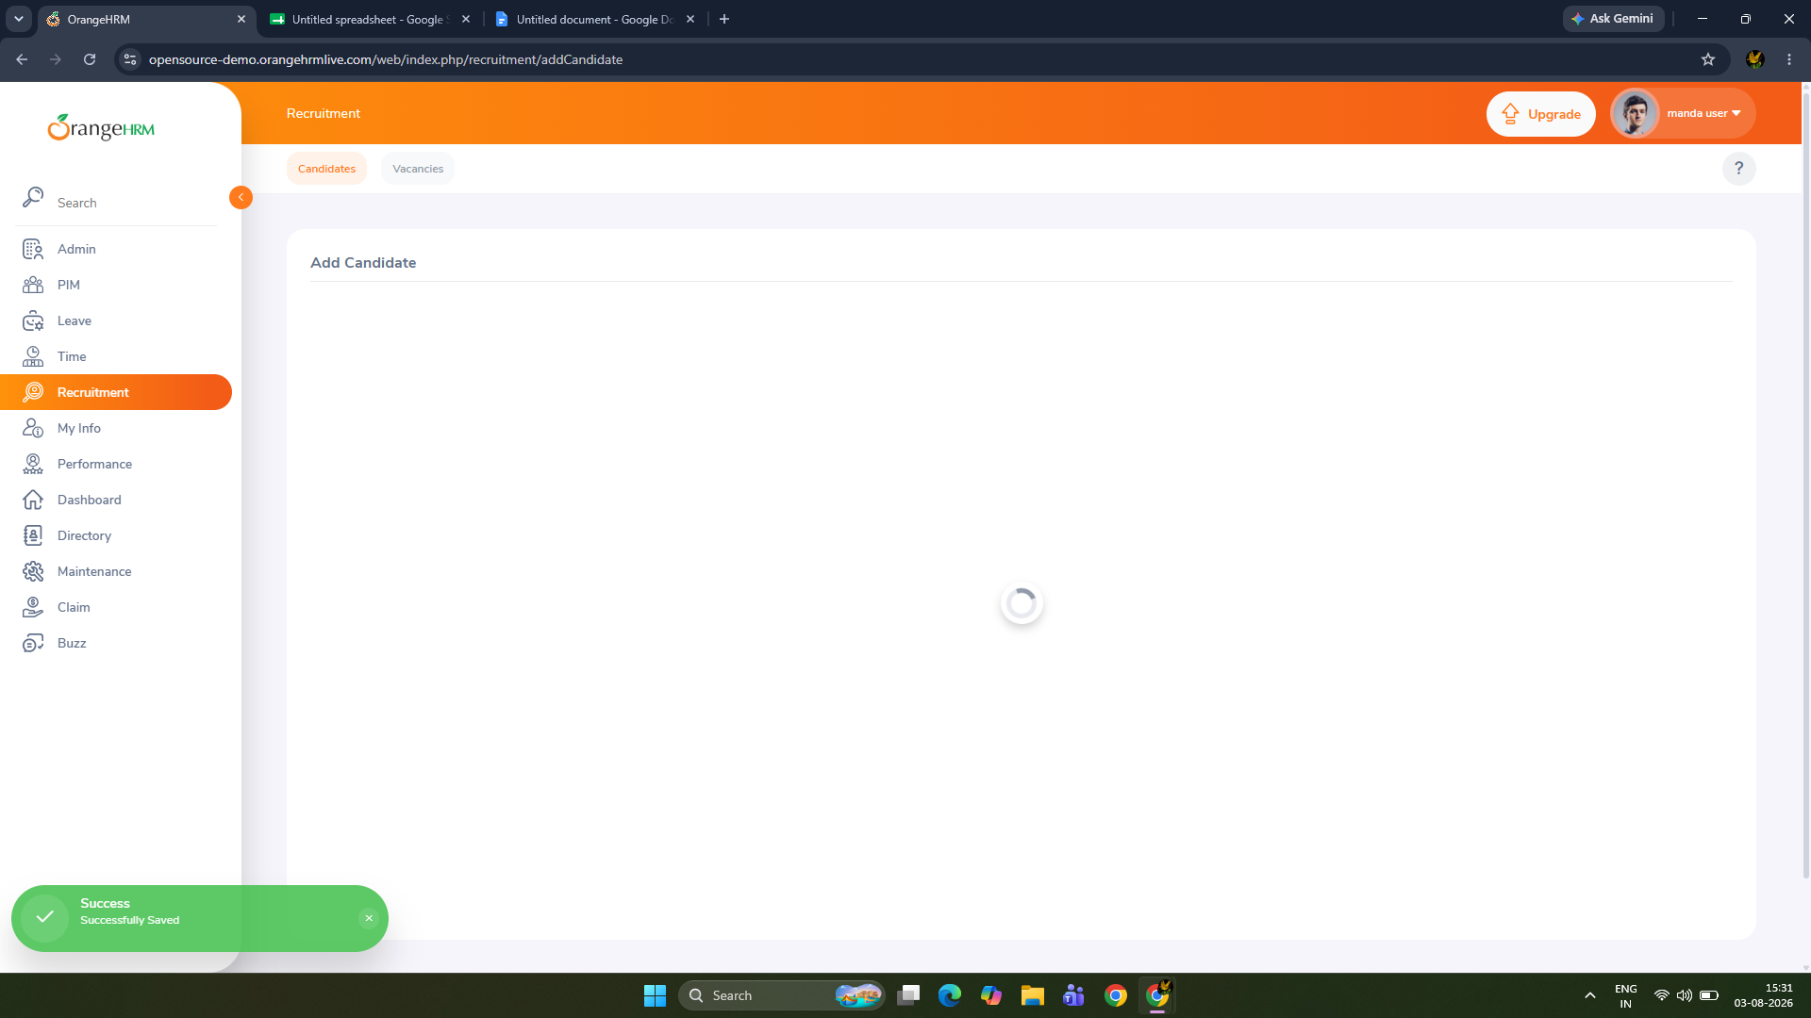

Scenario 02:Create a new requirement with valid data
Test case id :TC_03
Test steps:
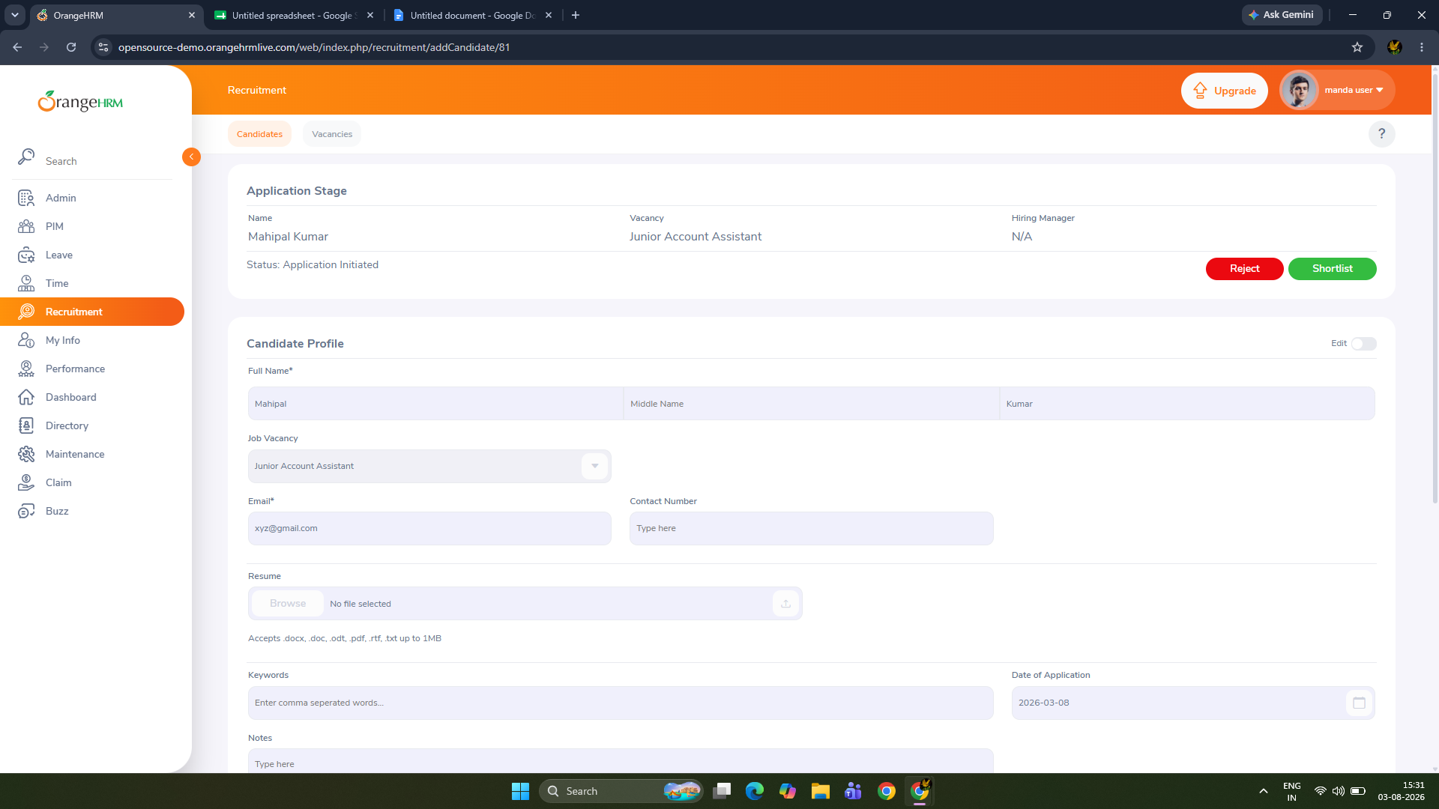
Enter mandatory fields and click Save
Scenario 03: Validate mandatory fields
Test case id :TC_04
Test steps: Leave mandatory fields blank and click Save
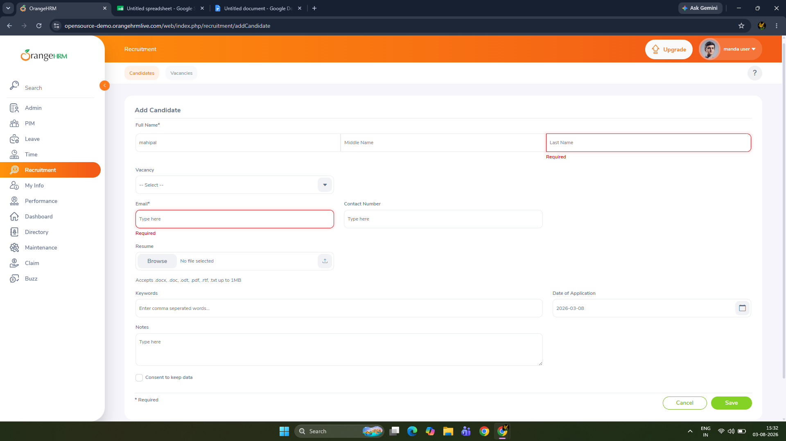

Scenario 04: Search by Job Title
Test case id :TC_05
Test steps:Search using Job Title
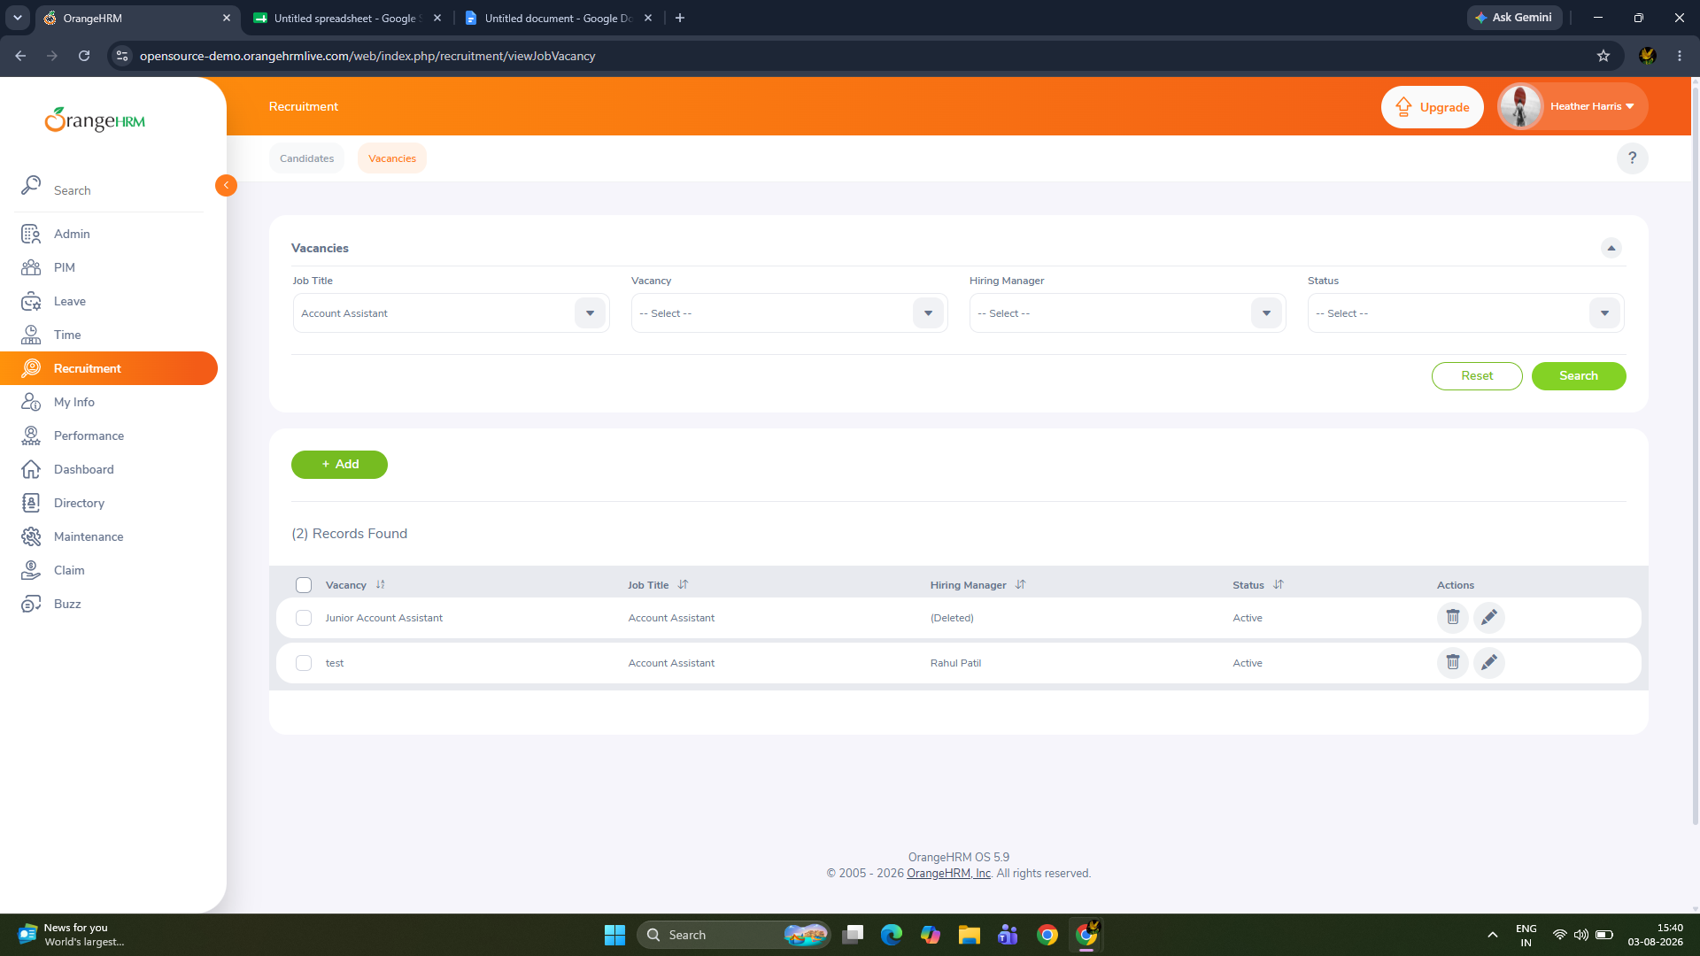
Scenario 05 : search by status
Test case id :TC_06
Test steps: select status >active
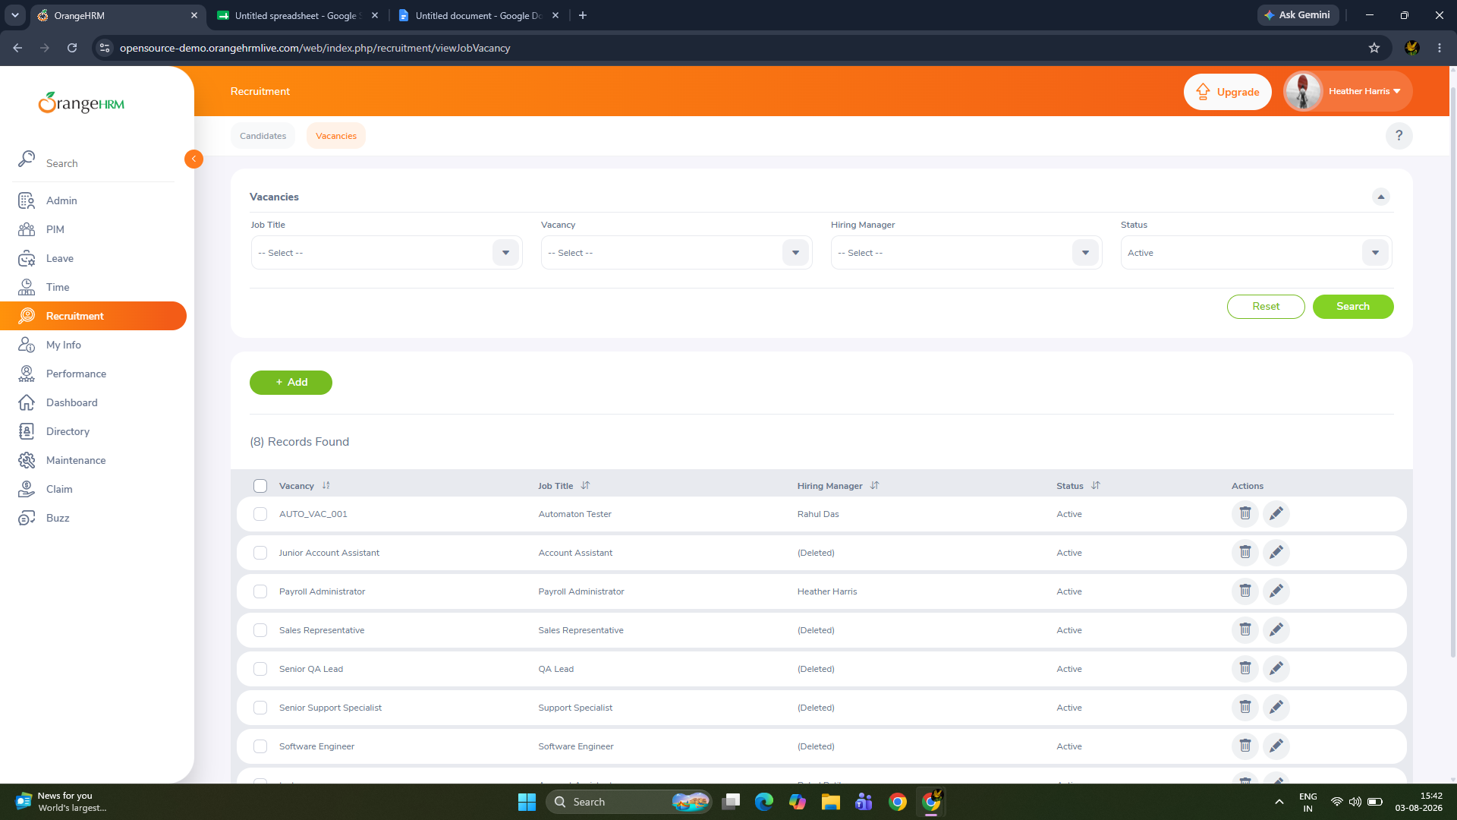

Scenario 06: delete requirement
Test case id :TC_08
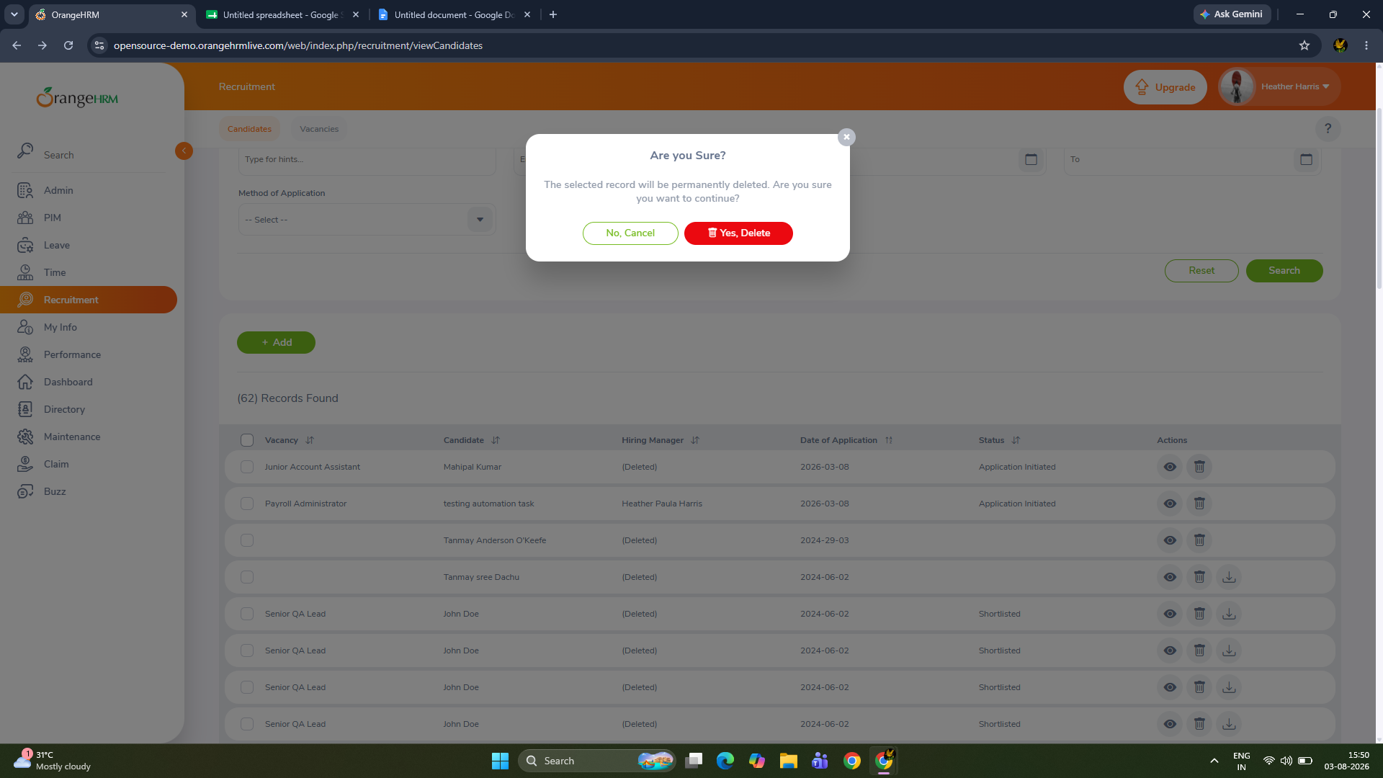
Test steps:Click Delete → Confirm

Scenario 07: Edit existing requirement
Test case id :TC_07

Test steps:
Edit contact and note

